**Open Field Test’s locomotor activity, Velocity, Acceleration in Corner, Border, and Center: from *.csv files**

# [C:\Users\amir1\AppData\Local\Microsoft\Windows\INetCache\Content.Word\Rat scientist having delema to moving fast with sparkling head in a open field test .jpg](http://www.openai.com/)Introduction

In animal tracking, distance, velocity, and acceleration are three important quantities that can provide insight into the movement and behavior of animals. Distance is a measure of how far an animal has moved over a given period of time. This can be measured using a variety of methods, such as tracking the animal's location using GPS or video tracking. Velocity is a measure of how fast an animal is moving. It is defined as the distance an animal travels divided by the time it takes to travel that distance. In animal tracking, velocity can be used to identify patterns in an animal's movement, such as whether it is moving in a straight line or changing direction frequently. Acceleration is a measure of how quickly an animal's velocity is changing. It is defined as the change in velocity divided by the time it takes for the change to occur. In animal tracking, acceleration can be used to identify changes in an animal's behavior, such as when it starts or stops moving or changes direction. All three of these quantities can be useful in animal tracking because they provide information about an animal's movement and behavior. By analyzing distance, velocity, and acceleration data, researchers can gain a better understanding of how animals move and interact with their environment.

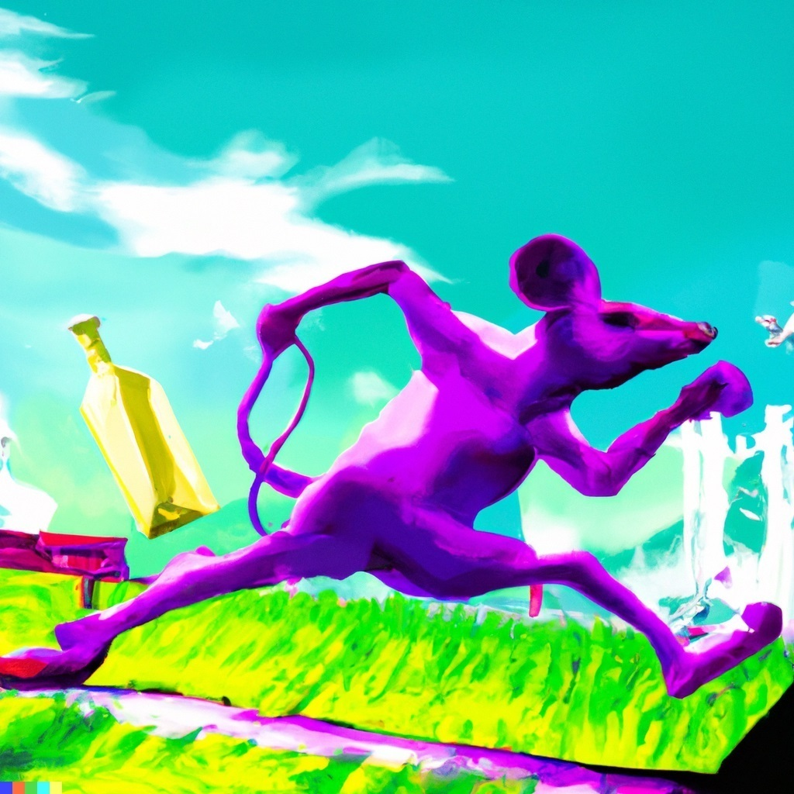

In the context of open field tests, these quantities can be used to understand the behavior of mice or rats under the influence of substances such as alcohol or nicotine. For example, distance and velocity can be used to measure the overall activity level of the mice or rats. Higher distance and velocity values may indicate higher levels of activity, while lower values may indicate less activity. This information can be used to understand how alcohol or nicotine addiction affects the activity levels of mice or rats. Acceleration can be used to measure changes in an animal's behavior, such as when it starts or stops moving or changes direction. This can be useful in understanding how alcohol or nicotine addiction affects the behavior of mice or rats. For example, researchers might observe that mice or rats under the influence of alcohol or nicotine exhibit more sudden changes in direction or have more rapid acceleration and deceleration compared to control animals. By analyzing distance, velocity, and acceleration data, researchers can gain a better understanding of how alcohol or nicotine addiction affects the movement and behavior of mice or rats in open field tests. This information can be used to identify specific behaviors that may be influenced by these substances, which can help researchers better understand the underlying mechanisms of addiction and identify potential therapeutic targets.

# How to get CSV files

EZ-Track is a program used for analyzing animal behavior in laboratory experiments. It allows researchers to automatically track the movement and behavior of animals in real-time or using specialized software and hardware. With EZ-Track, researchers can set up virtual zones within an experimental arena and track the animals as they move around. This can provide valuable information about the animals' behavior, such as how much time they spend in each zone, how many times they cross into each zone, and what types of behaviors they exhibit in each zone. EZ-Track can also be used to analyze other aspects of animal behavior, such as the animals' locomotion and movements, their social interactions, and their response to stimuli. This can provide valuable insights into the animals' behavior and help researchers better understand their psychological and physiological processes. So, EZ-Track is a useful tool for studying animal behavior in the laboratory, and it can provide valuable insights into the psychological and physiological processes underlying animal behavior. Please keep in your mind that you would have following information in the “ROI_location” in csv file which are: 'c1', 'c2', 'c3', 'c4', 'b1', 'b2', 'b3', 'b4' , 'center', 'b1_center', 'b2_center', 'b3_center', 'b4_center', 'c1_b1', 'c1_b4', 'c4_b4', 'c4_b3', 'c3_b3', 'c3_b2','c2_b2', 'c2_b1' ,'non_roi'. So, might you find it helpful in the animal directionality related studies, having some specific information about the crossing corner to border (c-b) imaginary lines (which are literally infinitesimally narrow lines in program), or border to center (b-center) would be an advantage, and there is some unpublished implication, as like has been shown in **Figure 1** just for one csv file as an example.

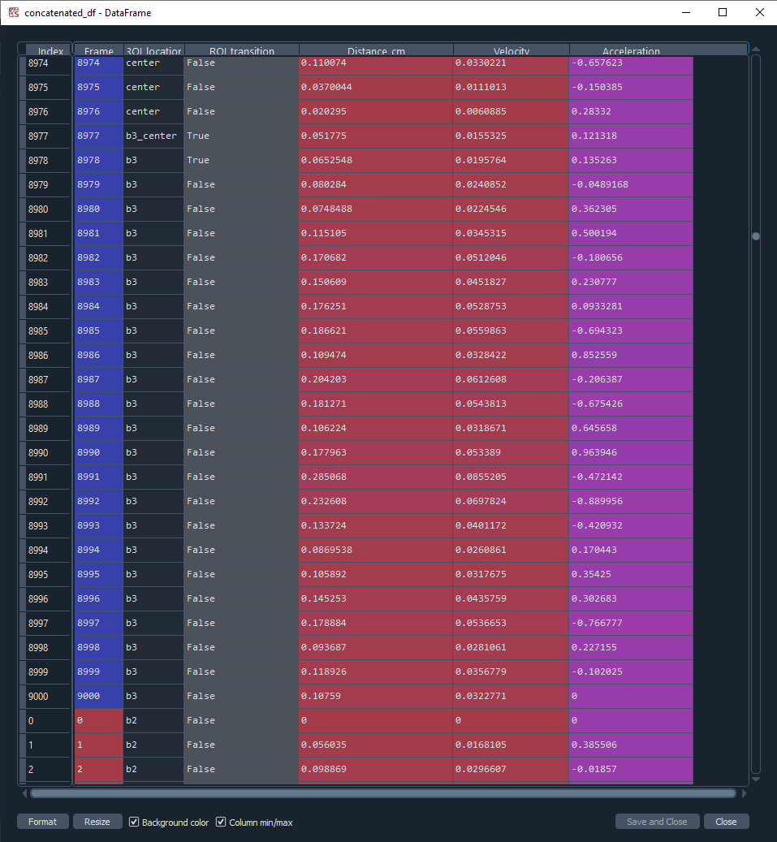

**Figure 1:** Theillustration of extractable information from EZ-Track program for open field test

# How this code helps

This code reads in a series of CSV files from a specified directory, processes the data in each file, and then concatenates the processed data into a single DataFrame. The processing steps involve calculating the acceleration of the animal, dropping rows with an index greater than 9000 (corresponding to frames beyond 5 minutes of the open field test), and selecting a subset of columns from the original data. Finally, the resulting concatenated DataFrame is saved to a new CSV file.

Here is a more detailed explanation of the code:

The path variable specifies the directory where the CSV files are located. The glob module is used to get a list of all the CSV files in this directory. The df_single list is initialized to an empty list. This list will be used to store the processed data from each CSV file. The code enters a for loop, where f is a filename from the list of CSV files. Inside the loop, the code reads in the CSV file using pd.read_csv() and stores the resulting DataFrame in a variable called df. The code then creates a new DataFrame called df2 by dropping rows from df with an index greater than 9000. Next, the code initializes an array of zeros called acceleration with the same length as df2. The code then calculates the velocity of the animal by multiplying the distance traveled (in centimeters) by a coefficient that converts the distance to meters and the time to seconds. The resulting values are stored in a new column called Velocity in df2. Flowingly, code imports the required libraries, sets the path to the directory containing the CSV files, that has been obtained from Ez-tracker program to extract entries to corner, border, and center in conjugation with the frames which they spend in each single targeted section and cleared in Figure 1. This code uses the glob module to get a list of all CSV files in that directory.

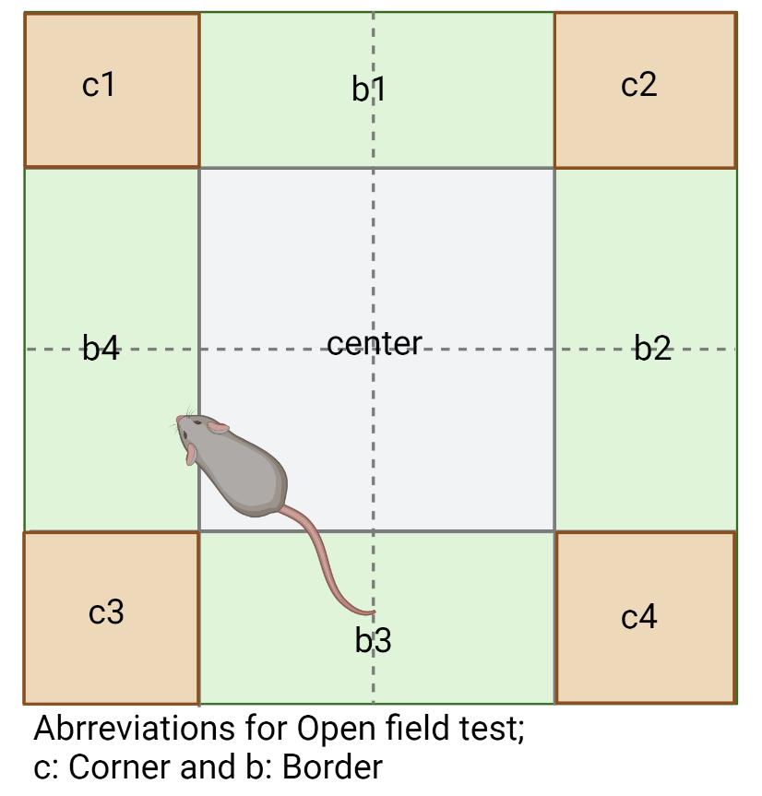

**Figure 2:** Represents the open field test imaginary sectioning to measure behavior related subjects

# Use of travelled Distance, Velocity, Acceleration open field test

In animal tracking, distance, velocity, and acceleration can be calculated using a combination of tracking data and mathematical formulas. These quantities are important in the context of open field tests because they can provide insight into the movement and behavior of mice or rats under the influence of substances such as alcohol or nicotine. To calculate distance, researchers can use tracking data to measure the distance traveled by the mice or rats over a given period of time. This can be done using a variety of methods, such as tracking the animal's location using GPS or video tracking. Once the distance data has been collected, it can be analyzed to understand how alcohol or nicotine addiction affects the distance traveled by the mice or rats. To calculate velocity, researchers can divide the distance traveled by the mice or rats by the time it took to travel that distance. This will give a measure of the speed at which the animals are moving. By analyzing velocity data, researchers can understand how alcohol or nicotine addiction affects the speed at which the mice or rats are moving.

To calculate acceleration, researchers can use the formula acceleration = (change in velocity) / (time taken for the change). This formula measures how quickly the velocity of the mice or rats is changing over time. By analyzing acceleration data, researchers can understand how alcohol or nicotine addiction affects the changes in the movement of the mice or rats. For example, researchers might observe that mice or rats under the influence of alcohol or nicotine exhibit higher acceleration values compared to control animals, indicating more sudden changes in movement. Alternatively, they might observe that the acceleration values of mice or rats under the influence of alcohol or nicotine are lower than those of control animals, indicating slower changes in movement. Understanding these patterns can provide insight into the effects of alcohol or nicotine addiction on the movement and behavior of mice or rats in open field tests.

# Conclusion

EZ-track is a system that can be used to measure various physical quantities related to the movement of an object, such as distance traveled, velocity, and acceleration. The system typically consists of sensors and a computer or other data processing device that can be used to collect and analyze data from the sensors.

In an open field test, EZ-track can be used to measure the distance traveled by an object, such as a person or vehicle, over a specific period of time. The system can also measure the velocity of the object at different points in time, as well as the acceleration of the object as it changes speed. These measurements can be used to analyze the performance of the object and to identify any issues or problems that may be affecting its movement. EZ-track is often used in sports and other athletic activities to measure and analyze the performance of athletes, as well as in research and development to study the movement of vehicles and other objects. It can also be used in a variety of other applications where accurate measurements of distance, velocity, and acceleration are needed.